Odoo – Products

Contents

What is a Product? 1

Units of Measurement 1

Creating a Product 2

# What is a Product?

A product in Odoo is anything that can be purchased, expensed or sold. A product can be either services, consumable items, or stocked items. Besides contacts, products are probably the most integrated records throughout Odoo and are used in many other modules or Apps in Odoo.

# Units of Measurement

Different Units of Measurement (UoM) can be created for both selling and purchasing products. For example, service products may be sold by ‘each unit’ or by ‘hours’. The company may also purchase a single ‘pack’ of items, which may contain 10 items, then sell them individually. Units of measure in Odoo allows for this flexibility.

Units of Measurement have categories which can be used on UoMs to organize and describe the purpose. Most of the categories built into Odoo will be enough but you can create new ones if needed via the Inventory App/**Configuration**/**UoM Categories** menu. Example categories are: Unit, Weight, Working Time, Length/Distance, Volume.

To edit or create UoM:

1. In the Inventory app, go to **Configuration** then **UoM**.

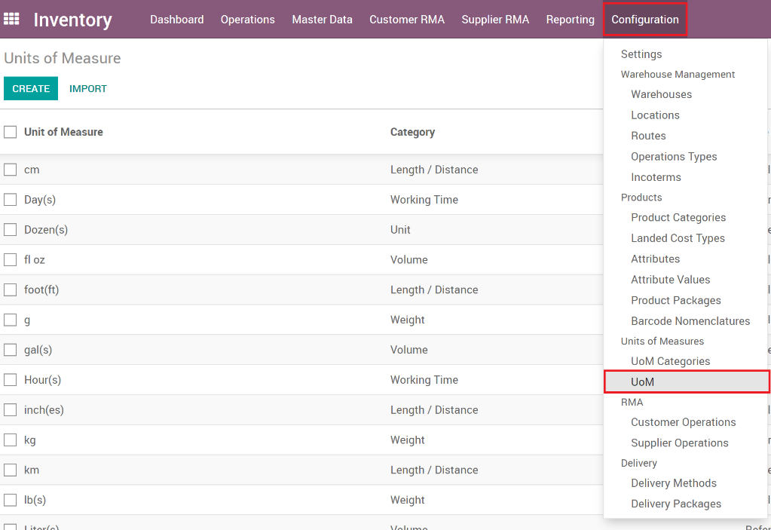

1. Open the UoM you want to edit or click the **Create** button to create a new one.
2. Enter the required fields

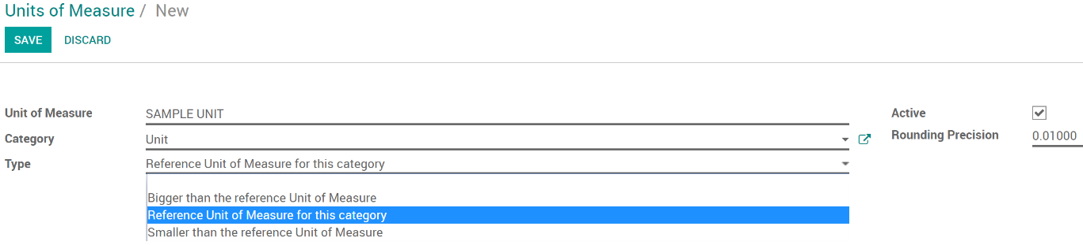

Field Descriptions:

* 1. **Unit of Measure**: Name of the UoM that is visible to users.
  2. **Category**: Category that the UoM is set for.
  3. **Type**: Used for when there is a difference in purchase vs sales.
     1. **Bigger than the reference Unit of Measure**: example if UoM was ‘Ton’.
     2. **Reference Unit of Measure for this Category**: example if UoM was ‘Kilograms’.
     3. **Smaller than the reference Unit of Measure**: example if UoM was ‘Grams’.
  4. **Active**: Whether this UoM is active and can be used by users.
  5. **Rounding Precision**: Rounds the computed quantity to this precision.

# Creating a Product

Since Odoo uses products throughout many different modules or Apps, many apps have a products section where users can view and create Products if the user has permissions to do so. For example, the Sales, Inventory, Field Service and Purchase apps all have accessibility to create products. This document will show how to create products using the Inventory app but it’s very similar in any other app that has products in it.

1. In the Inventory App and go to **Master Data** then **Products**.
2. Open the Product to edit it or click the **Create** button.

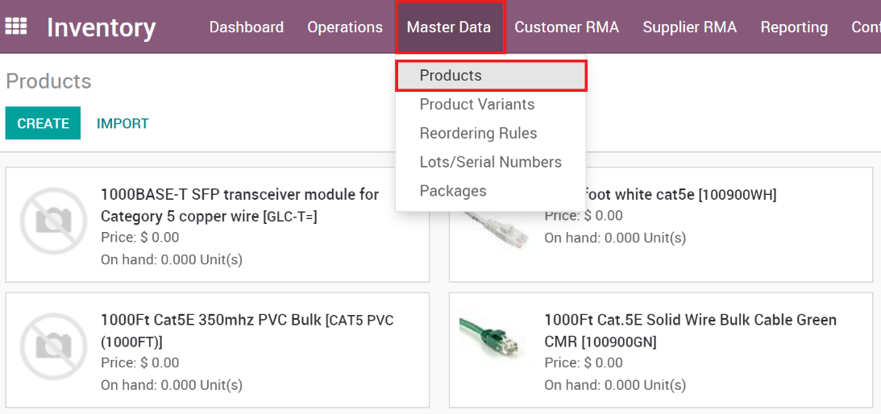

1. Products contain a lot of information so fill as many fields as possible

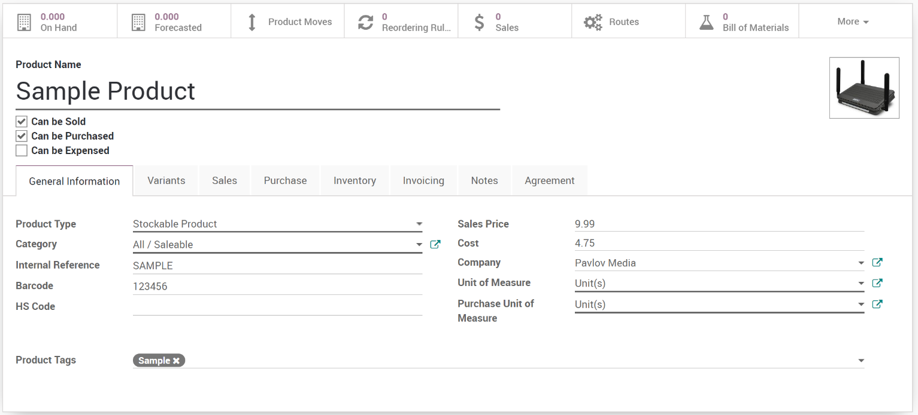

Field Descriptions:

* 1. **Name**: Descriptive name of the product.
  2. **Image**: A basic image can be set on the product to help users visibly see the product.
  3. **Can Be Sold**: Whether the product can be included on Sales Quotes and Orders.
  4. **Can Be Purchased**: Whether the product can be included on Purchase Orders.
  5. **Internet Reference**: An internal only reference that isn’t visible to customers or vendors.
  6. **Barcode**: UPC or Barcode for the product.
  7. **HS Code**: Used for international shipping.
  8. **Sales Price**: Default sales price for the product but can be overridden by sales pricelists.
  9. **Cost**: Cost of the product. Can be manually entered or setup to be auto updated by standard/landed costs.
  10. **Company**: In a Multi-Company environment, if chosen to keep products separate for each company, then this field is set to the company that the product is part of.
  11. **Unit of Measure**: Different ‘Sold as’ units of measurement are allowed and this is where it’s set on the product.
  12. **Purchase Unit of Measure**: The product can be purchased in a different unit than it’s sold and this is where that is set.

Smart Button Descriptions:

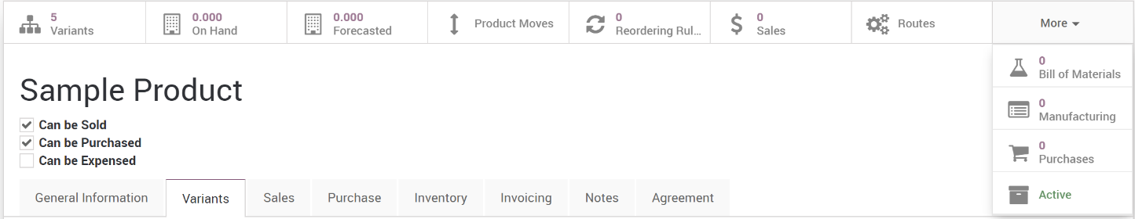

1. **Variants**: Counts and lists Variants of the product.
2. **On Hand**: The physical count of inventory for the product.
3. **Forecasted**: The count of inventory that is on non-confirmed sales quotes.
4. **Product Moves**: Counts and lists of inventory moves for the product.
5. **Reordering Rules**: Counts and lists rules to trigger auto-reordering of the product.
6. **Sales**: Sales quotes and orders that have this product.
7. **Routes**: Counts and lists the routes of the product like buy, purchase, manufacture, etc.
8. **Bill of Materials**: Counts and lists the BOM’s of the product.
9. **Manufacturing**: Counts and lists the manufacturing orders of the product.
10. **Purchases**: Counts and lists the purchase orders that contain the product.

Tab Descriptions:

1. **General Information**: Fields described above for the general information for the product.
2. **Variants**: Product Variant attributes and attribute values are listed here.

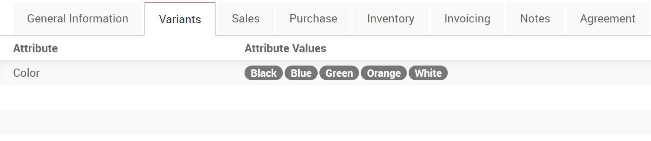

1. **Sales**: Contains the pricelists associated with the product as well as the warranty duration that the customers receives.

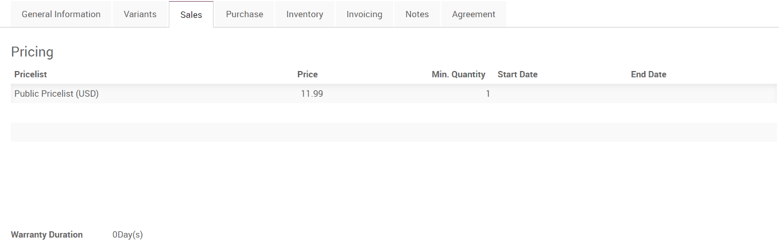

1. **Purchase**: Contains the Reordering rule setting for the product as well as the Vendor Pricelists.   
   **NOTE**: The first pricelist is used in the auto-reordering process.

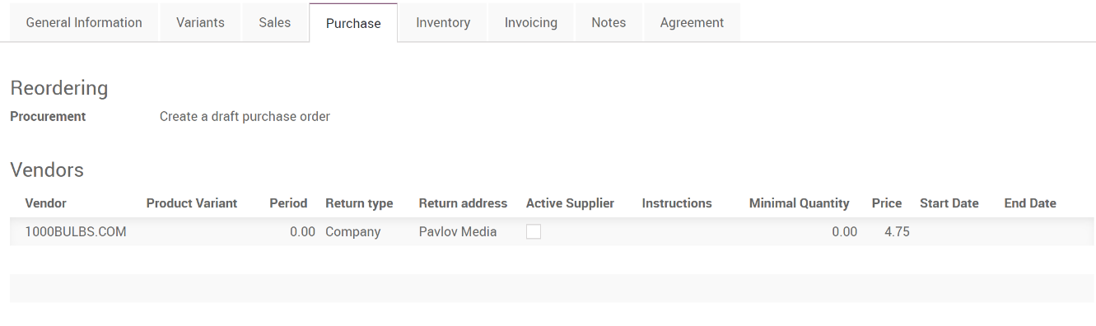

1. **Inventory**: Contains inventory specific configurations including routing, lead times, tracking and inventory locations. It also includes RMA inventory settings for the product.

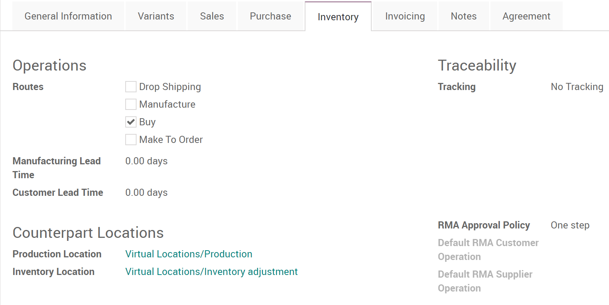

1. **Invoicing**: Contains configurable items for invoicing, taxes (both customer and vendor taxes), accounting and costing type.

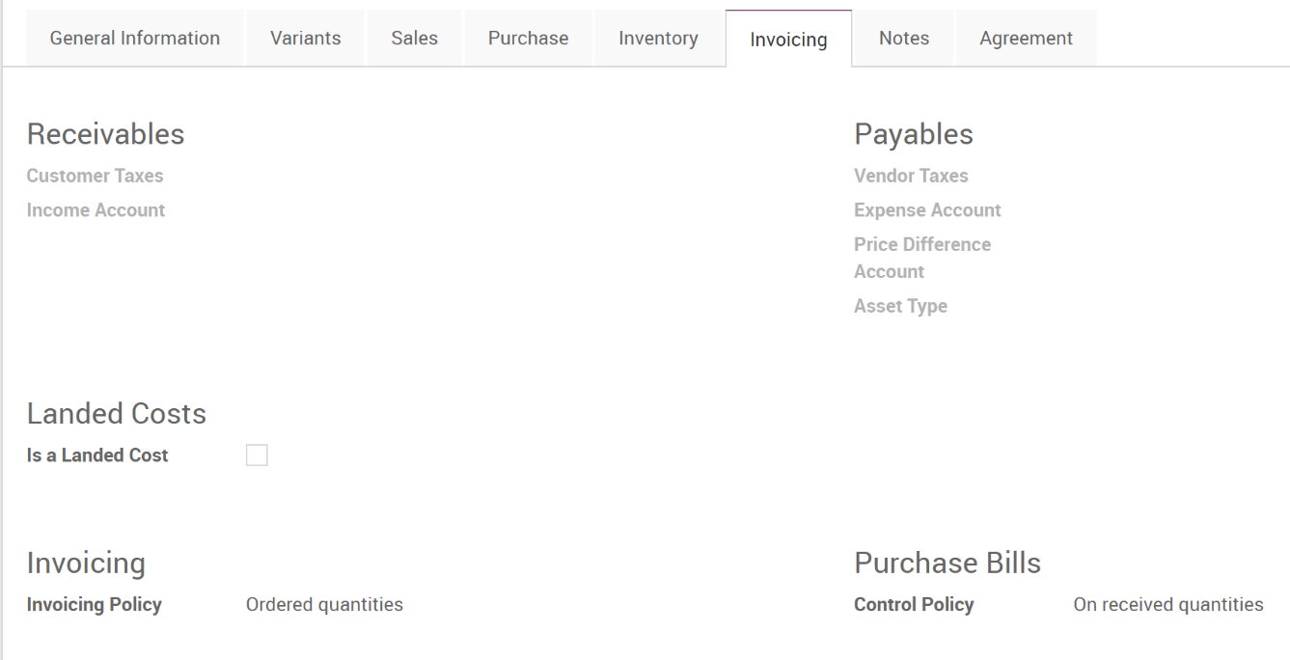

1. **Notes**: Contains notes and warnings for the other modules within Odoo.

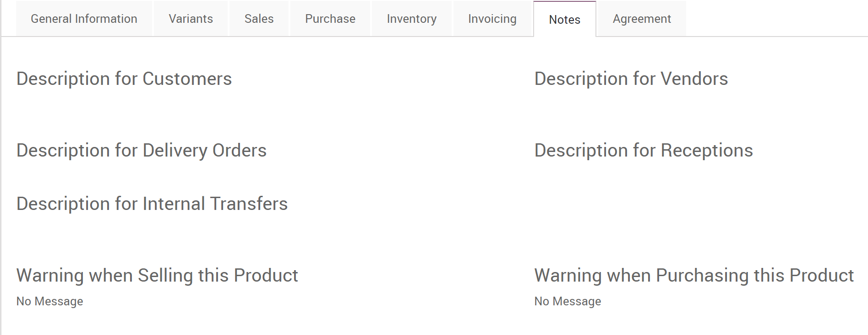

1. **Agreement**: Contains settings for agreements, particularly if this product will be visible to set as a Service Profile product or not.

